Project TumorTrace: MRI-Based AI for Breast Cancer Detection



Infosys SPRINGBOARD 5.0

Name : Suyash Panchal Company Name : Infosys Role : AI/ML Intern

Duration : 7th October 2024 – December 2024 Linkedln : <https://www.linkedin.com/in/suyash-panchal-4970b530a>

Github : <https://github.com/Suyashpanchal07/TumorTrace.git>

AI/ML Internship Assignments and Tasks

**Day-1**

8-10-2024

# Introduction to TumorTrace Project

Project TumorTrace focuses on using artificial intelligence (AI) to enhance breast cancer detection through MRI scans.

# Project dataset and basic concepts

Dataset used : <https://drive.google.com/file/d/1rKps09z1DEkfiICZlpIBOFek-LZ1vFAC/view>

Dataset files:

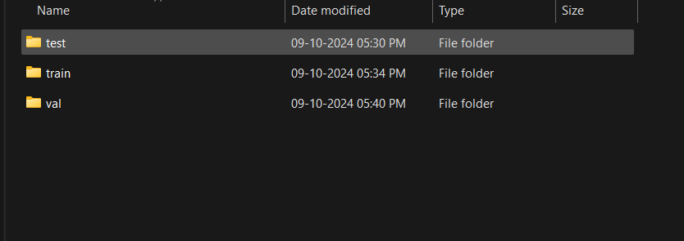

**Day-2**

9-10-2024

# Setting up GitHub and Python Environments

# 

**Day-3**

10-10-2024

# Understanding CNN architecture

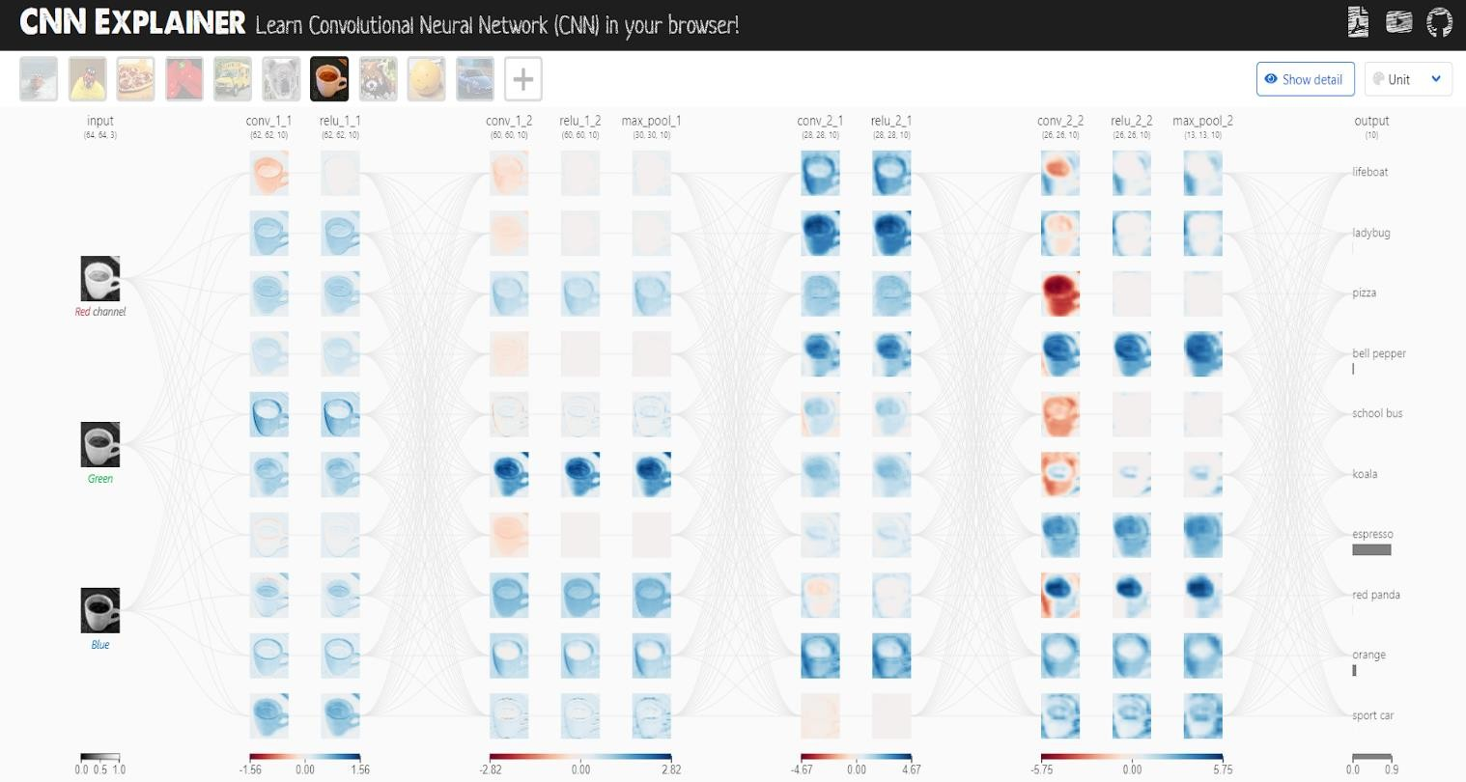Reference site - <https://poloclub.github.io/cnn-explainer/>

**Day-4**

11-10-2024

# Performing Exploratory Data Analysis

**Transformation:** The transform in PyTorch is set to resize the images to (224, 224) and convert them to tensors.

**Dataset Loading:** Used datasets.ImageFolder to load images, which assumes a directory structure where each subdirectory is a class.

**DataLoader:** Creates batches and shuffles the dataset.

**Image Display:** Adjusted the method to filter and retrieve images of a specific class and converted tensors to NumPy arrays for displaying with matplotlib.

import torch

from torchvision import datasets, transforms

from torch.utils.data import DataLoader

import matplotlib.pyplot as plt

# Define transformation (resize and convert to tensor)

transform = transforms.Compose([

transforms.Resize((224, 224)), # Resize all images to 224x224

transforms.ToTensor() # Convert images to PyTorch tensors

])

# Load the dataset from a directory

dataset = datasets.ImageFolder(D:\\Infosys Internship\\test', transform=transform)

# Create a data loader without splitting

data_loader = DataLoader(dataset, batch_size=1, shuffle=True)

# Iterate over a batch of images

for images, labels in data_loader:

# Convert tensor to numpy for displaying

img = images[0].permute(1, 2, 0).numpy() # Change dimensions for plotting

plt.figure(figsize=(5, 5))

plt.imshow(img)

plt.title(f'Label: {labels[0].item()}')

plt.axis('off')

plt.show()

break # Display only one image

## Implementing data augmentation techniques

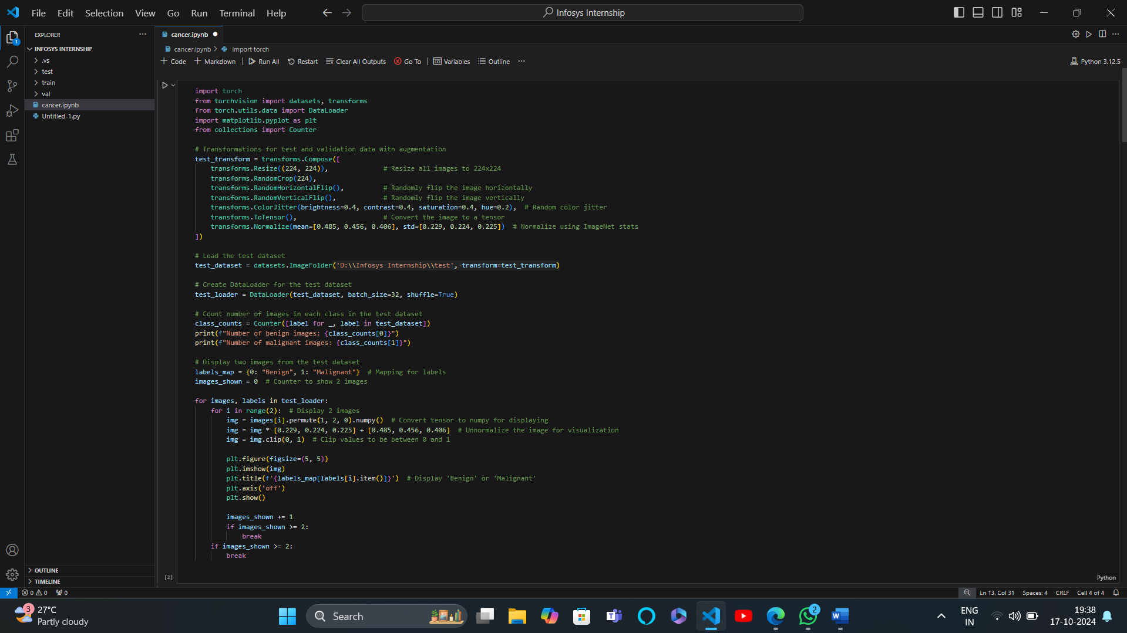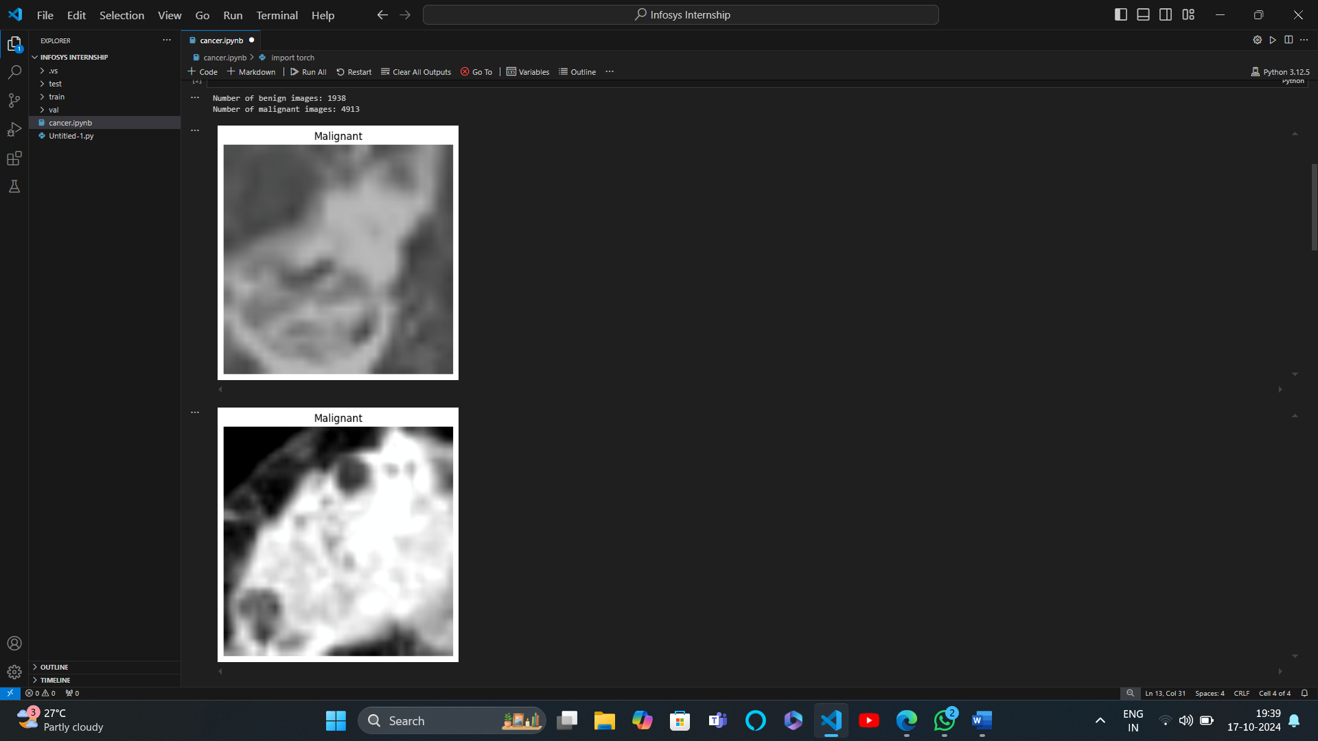

**Day-5**

14-10-2024

# Understanding ResNet and VGG16 architecture

**Day-6**

15-10-2024

Load a VGG16 Model

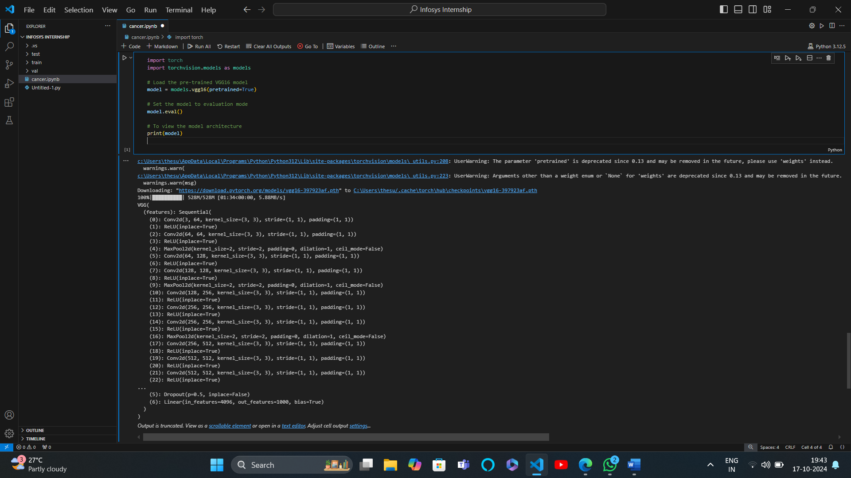

## IMPLEMENT HISTOGRAM OF ORIENTED GRADIENTS ,CORNER AND EDGE DETECTION

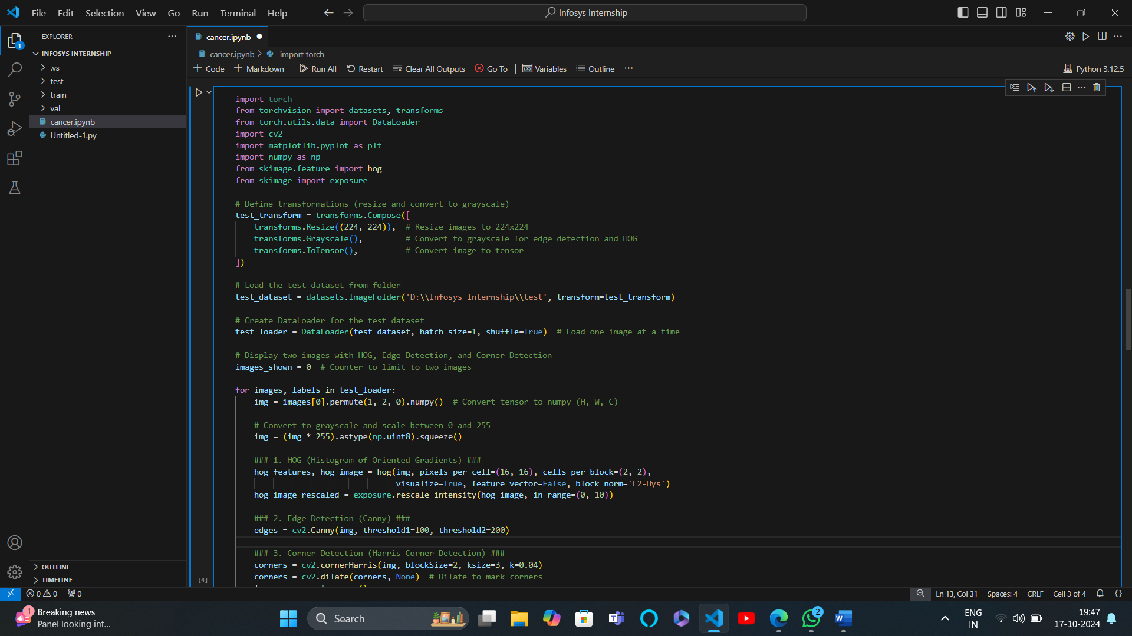

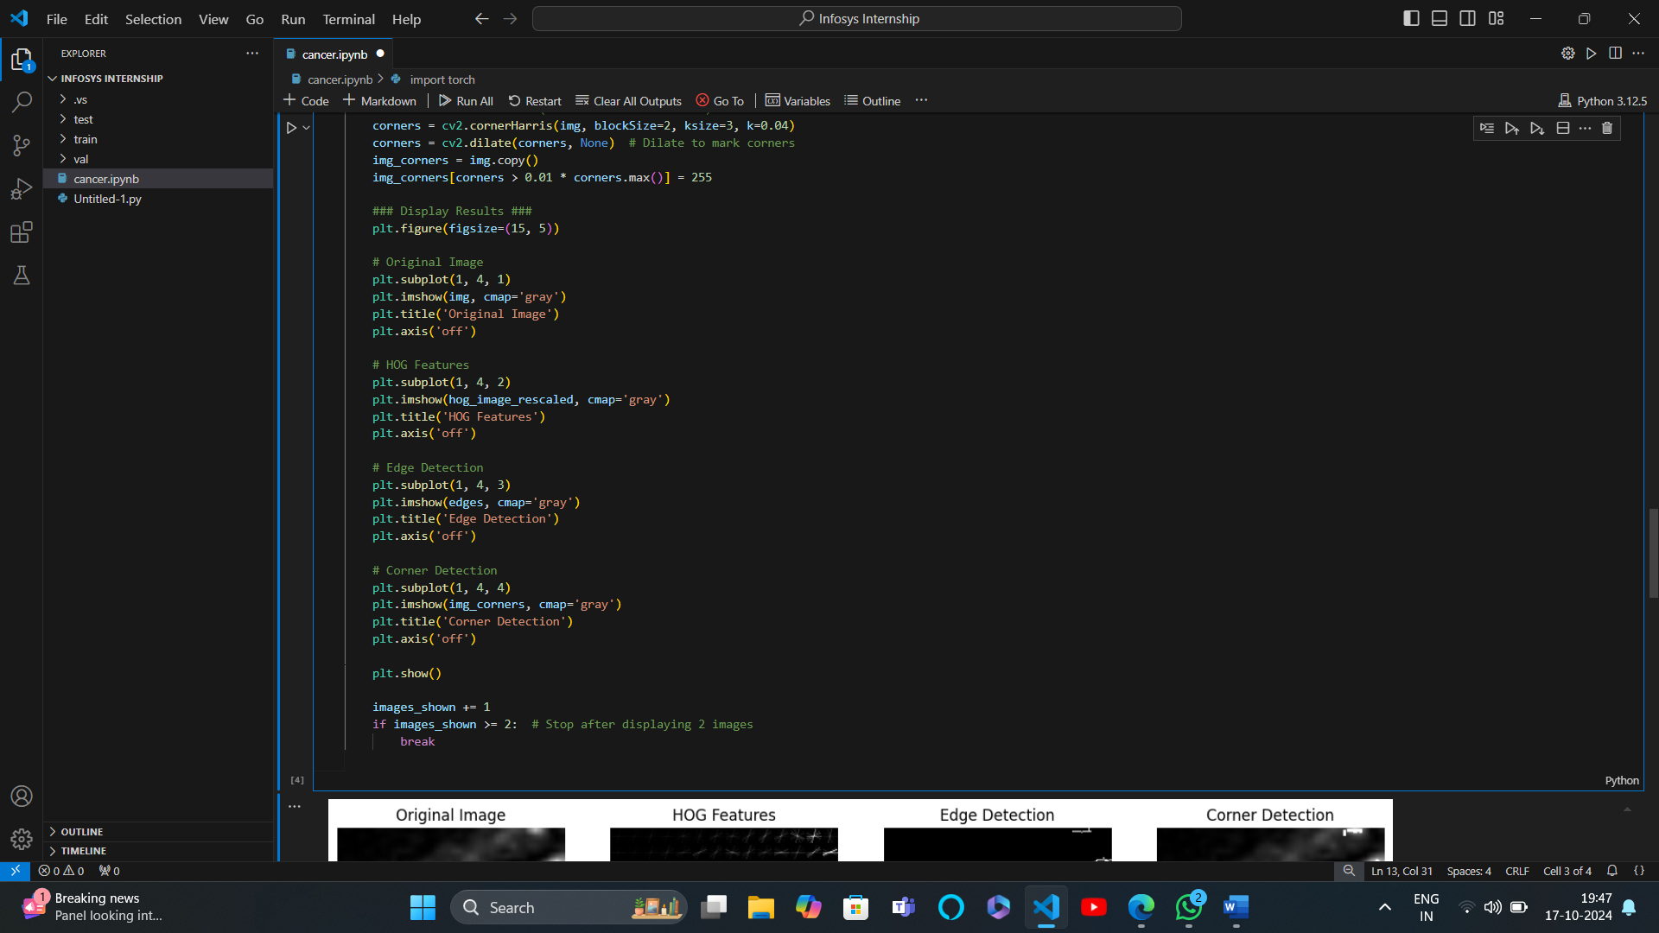

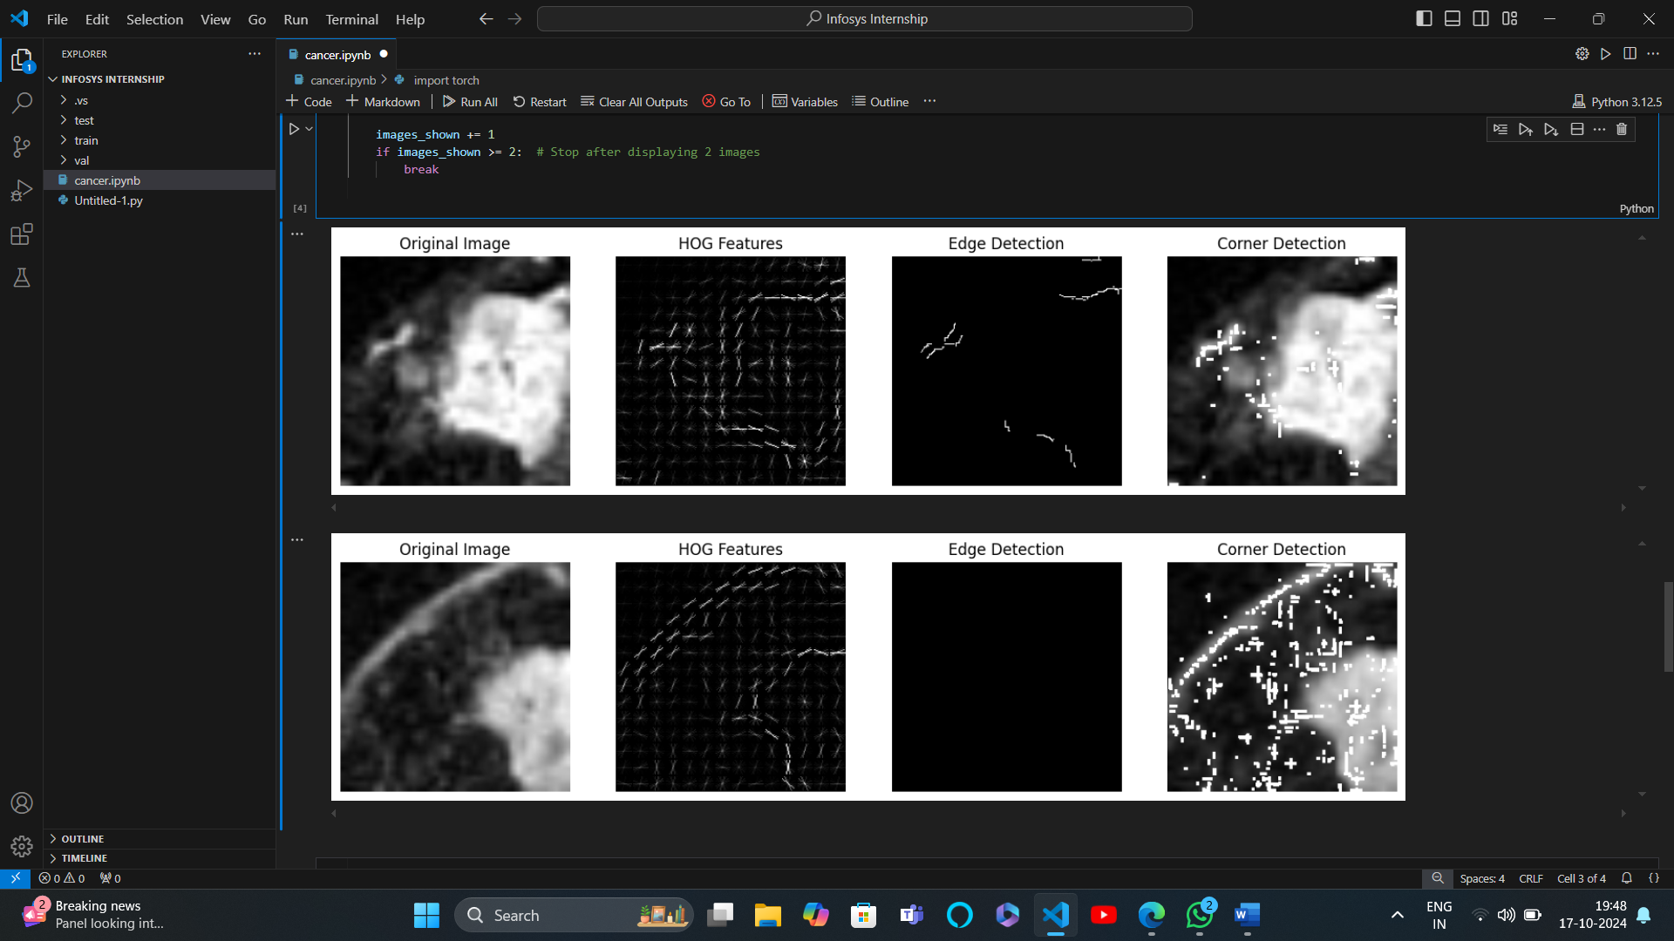

**Day-8**18-10-2024

**Day-9**21-10-2024

Implement Sobel Edge Detection

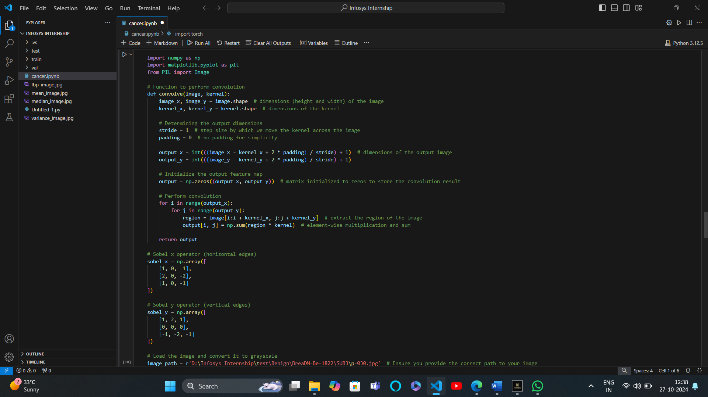

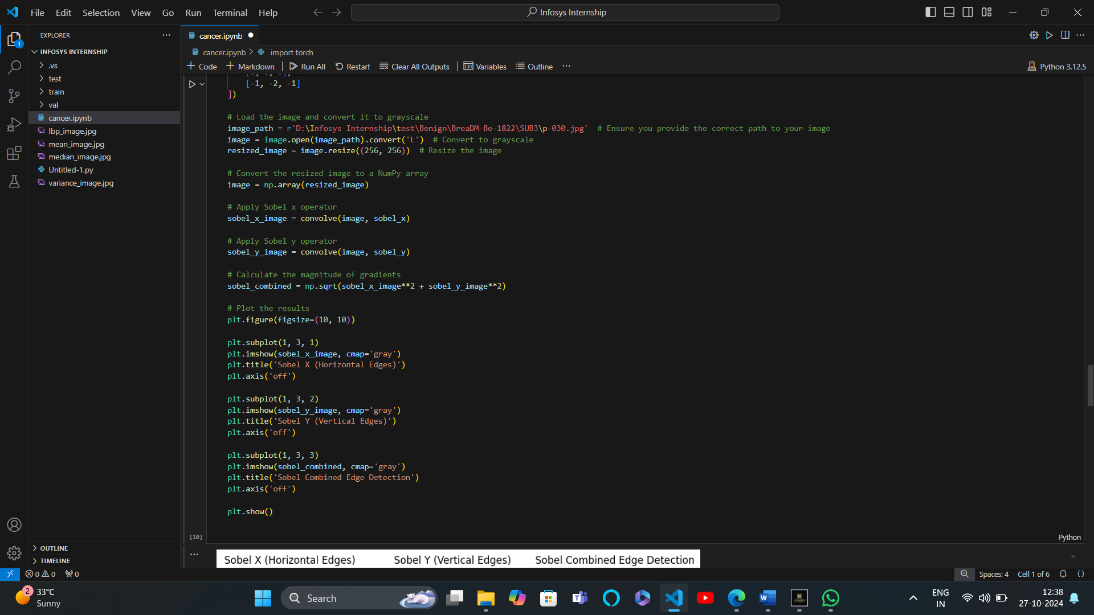

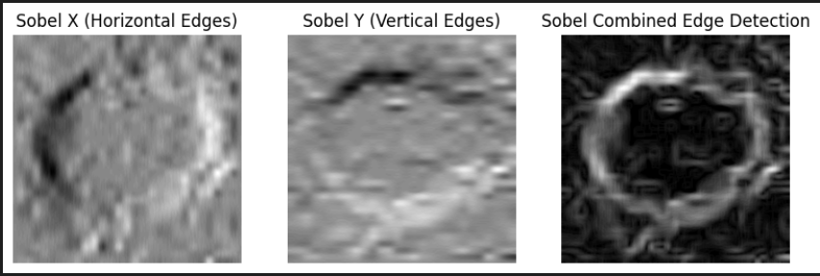

**Day-10**22-10-2024

Implement local binary pattern

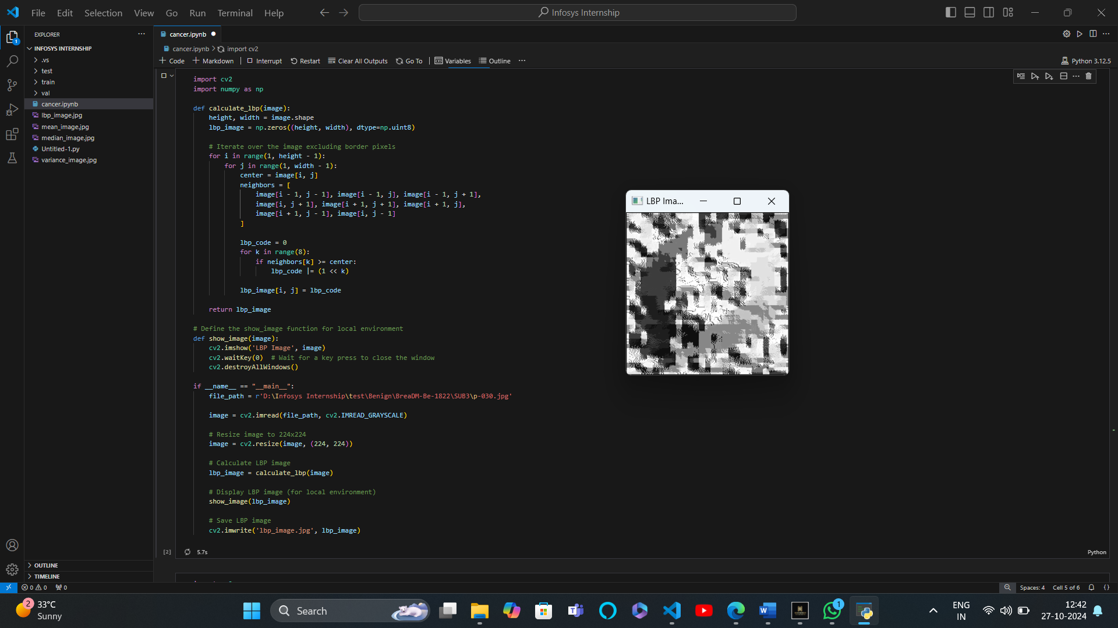

Implement mean binary points, median binary points,Variance binary points

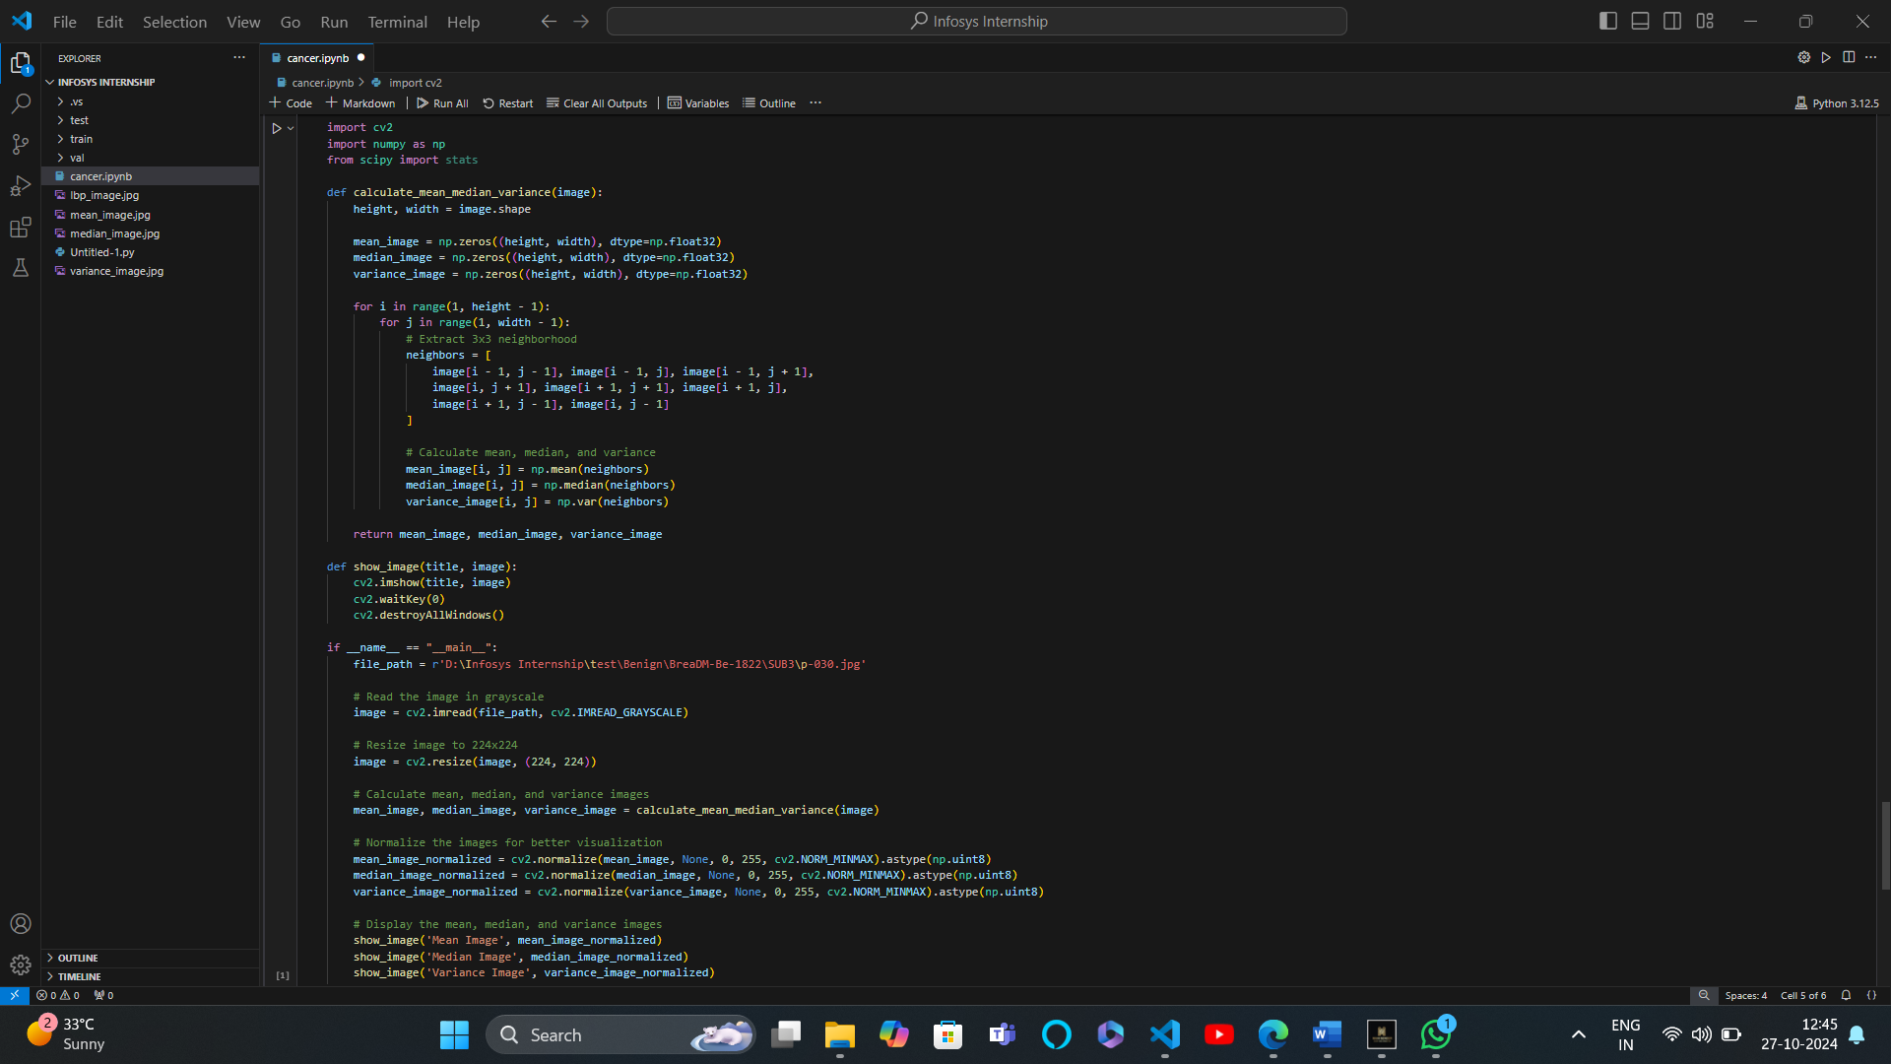

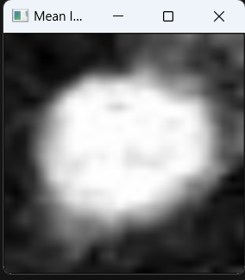

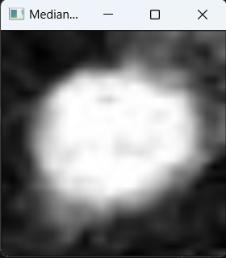

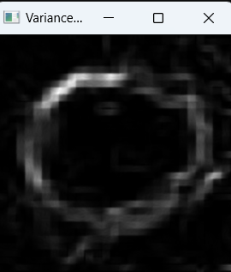

COMBINED MEAN-VARIANCE-MEDIAN LOCAL BINARY PATTERN (MVM-LBP)

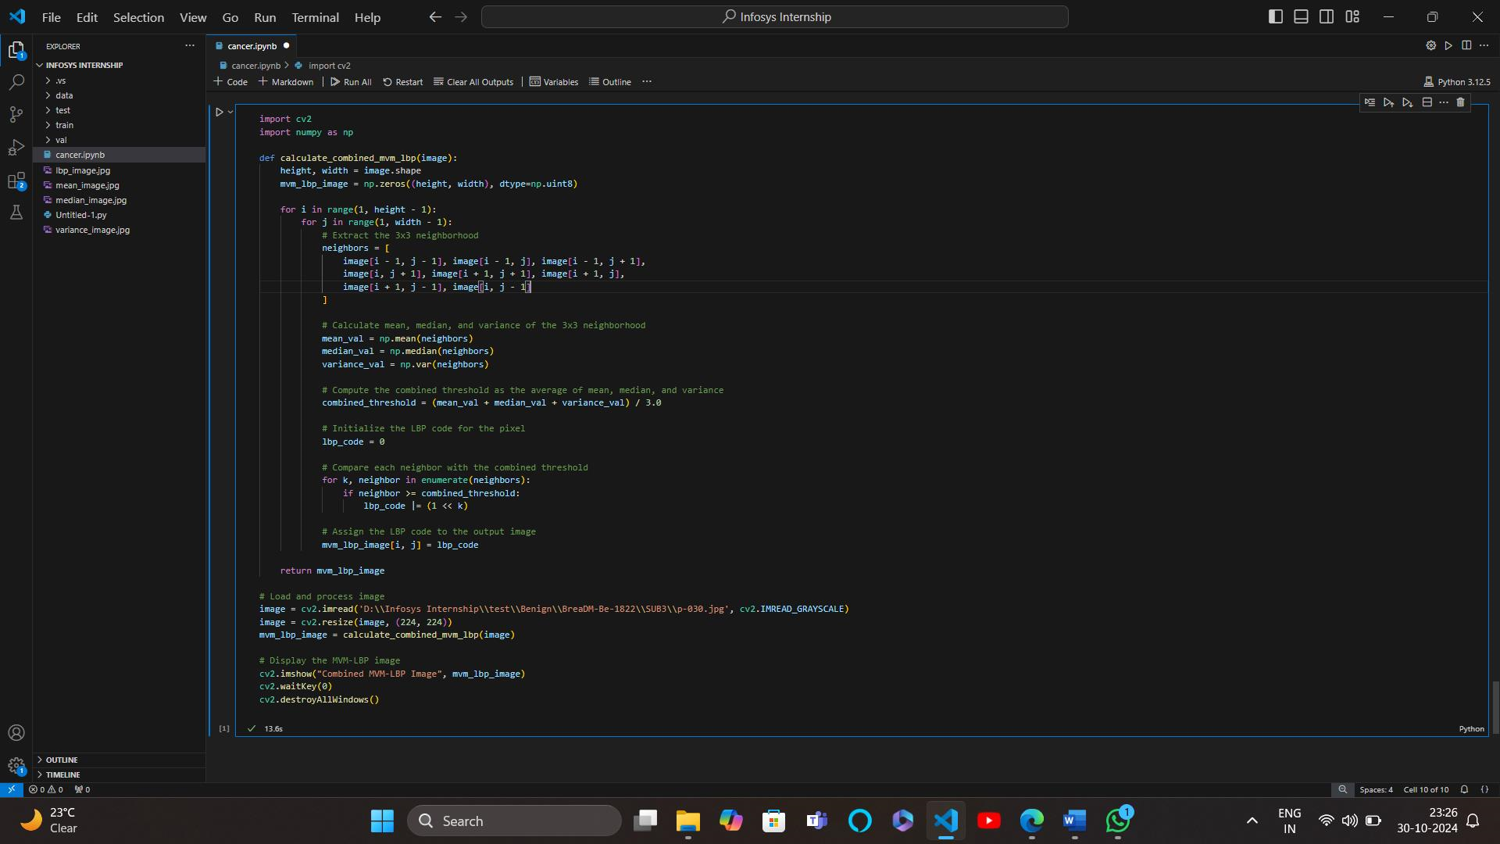

30-10-2024

GLCM (Gray-Level Co-occurrence Matrix)

Overview:

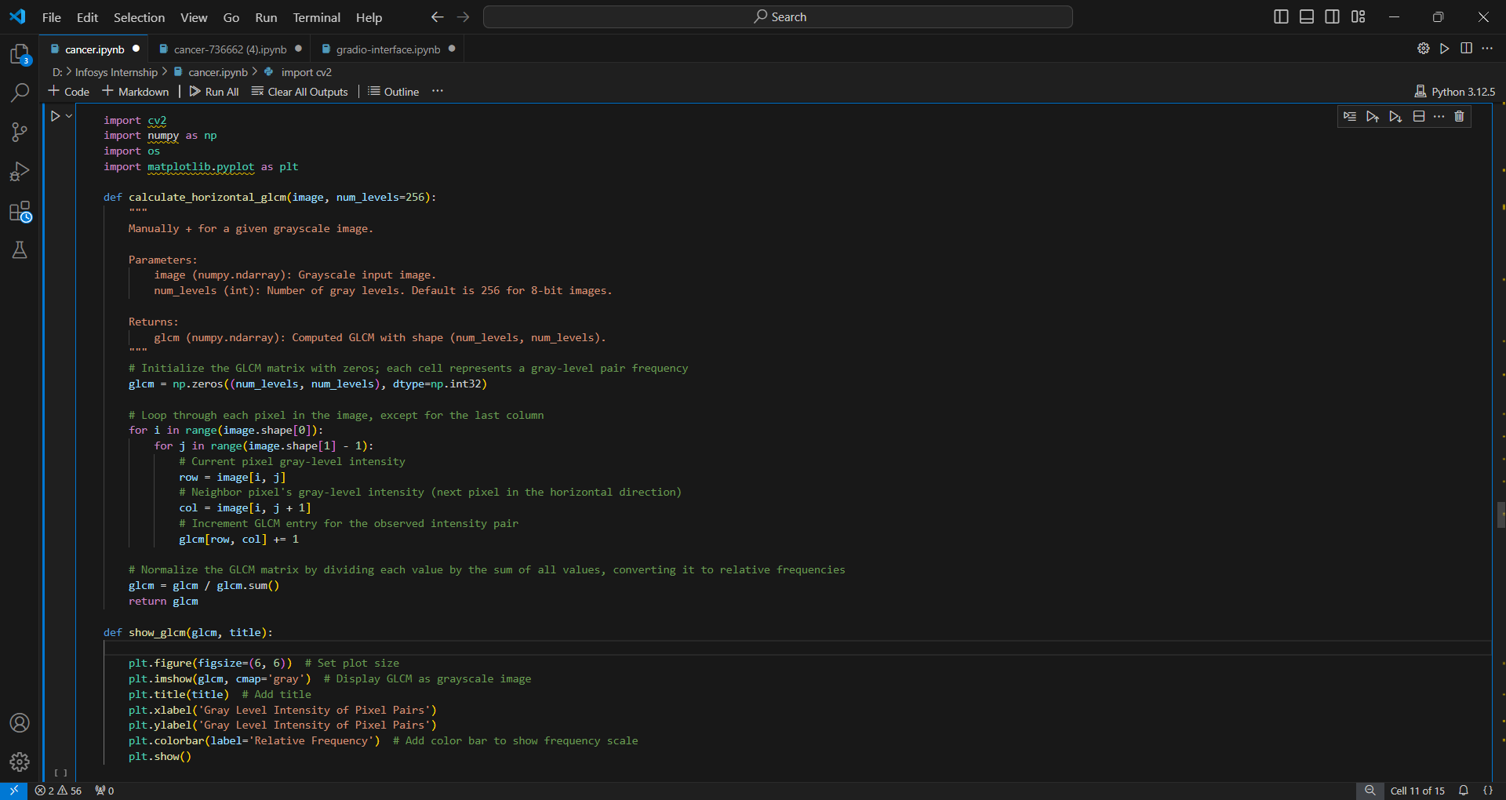

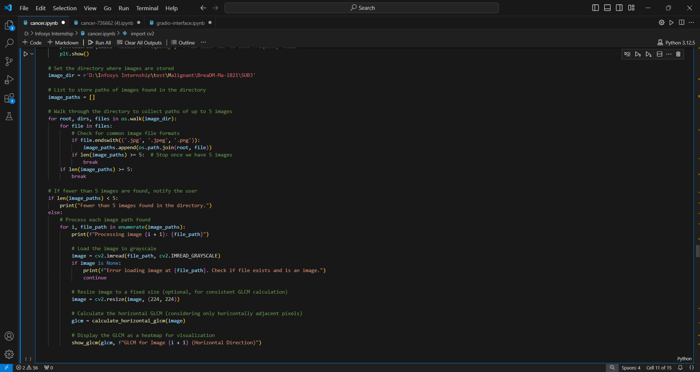

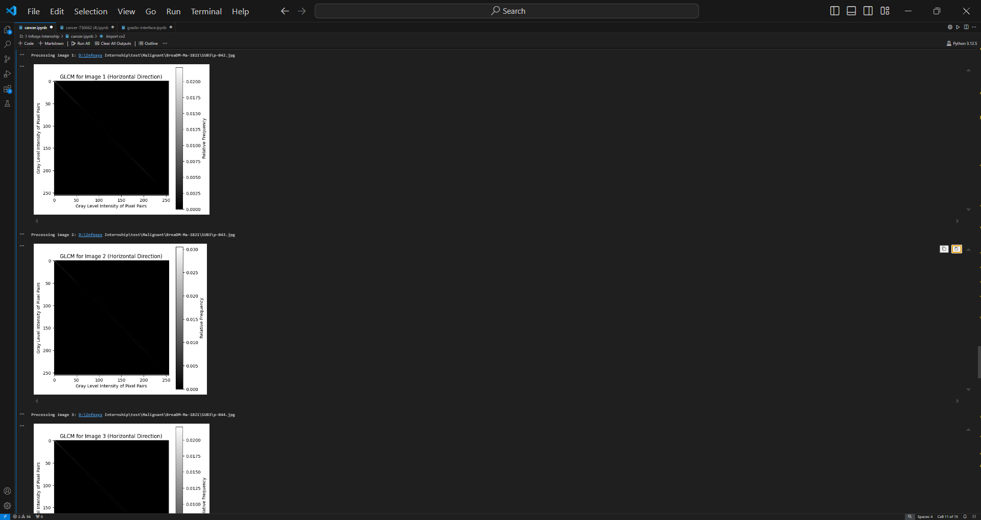

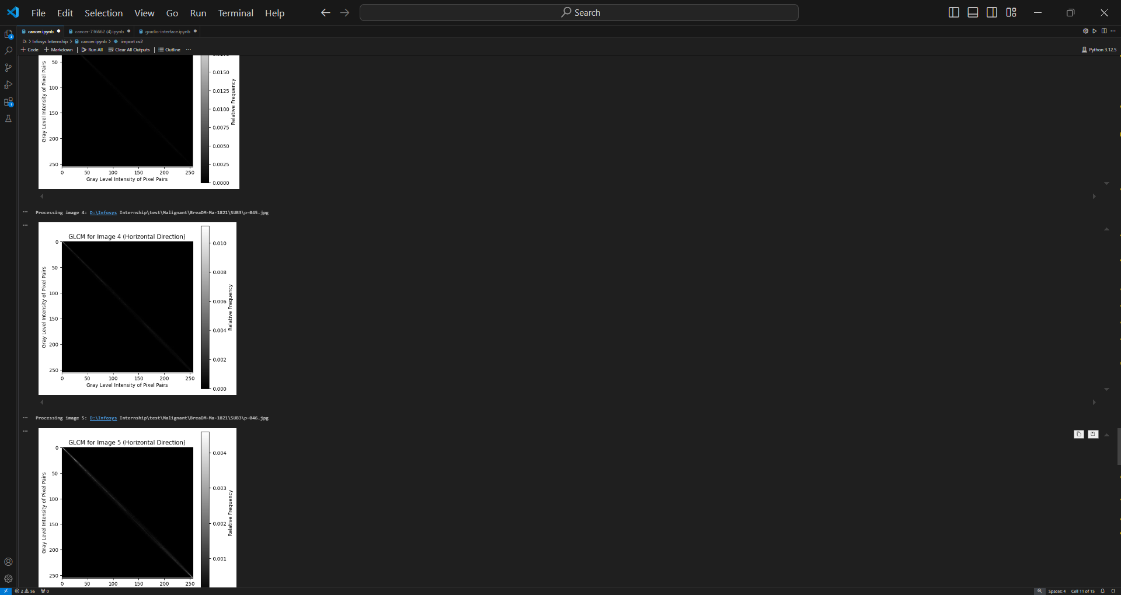

04-11-2024

**LOADING AND VISUALIZING VGG16**

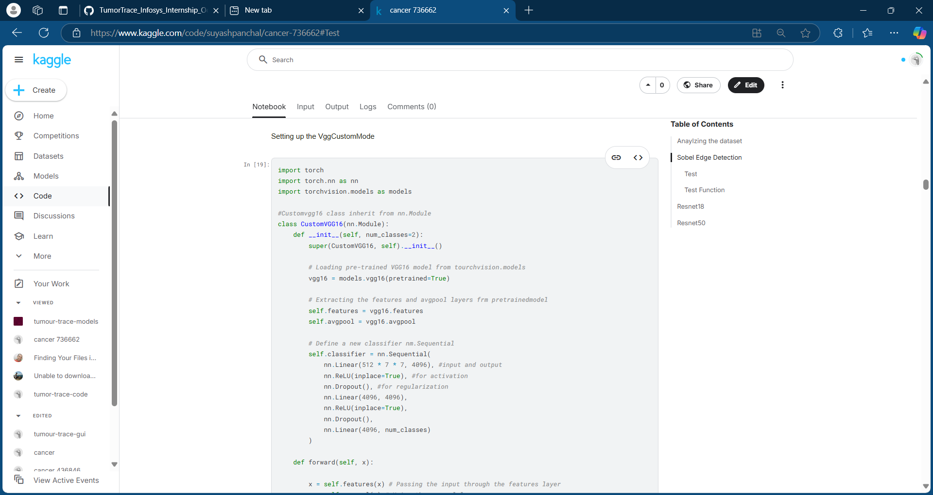

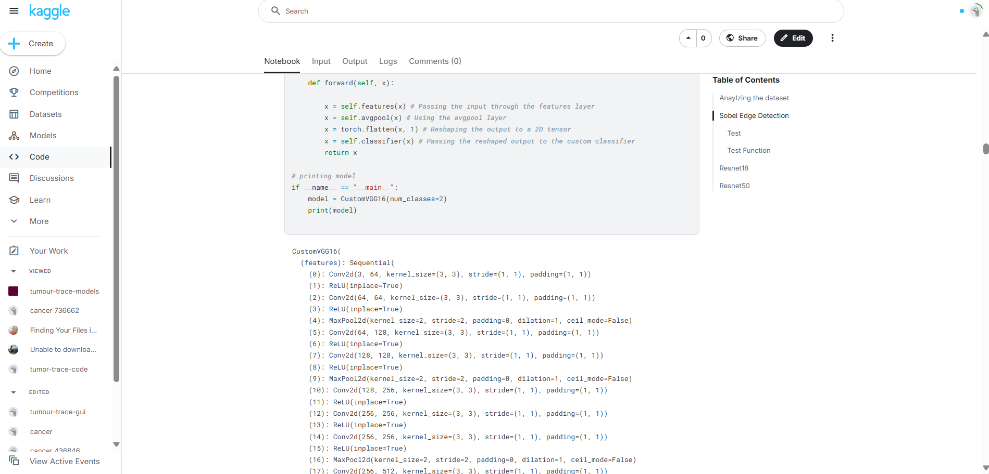

07-11-2024

CREATING EARLYSTOPPING CLASS FOR MODEL

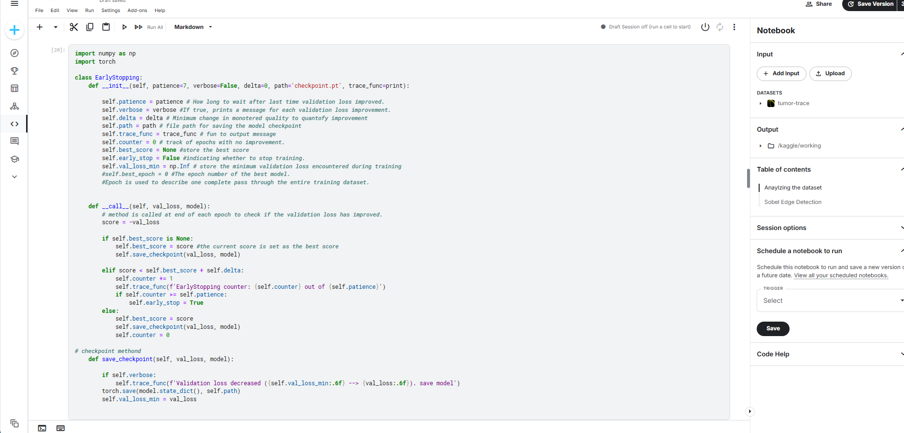

07-11-2024

TRAIN CLASS

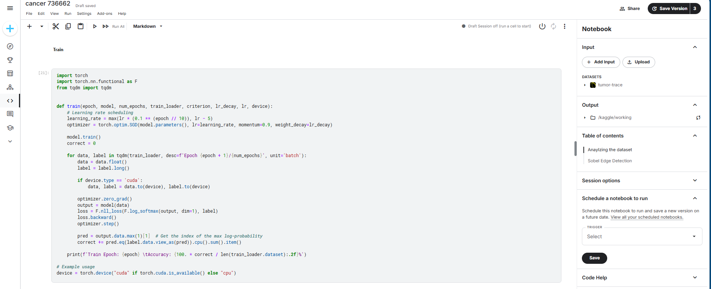

08-11-2024

VALIDATION CLASS

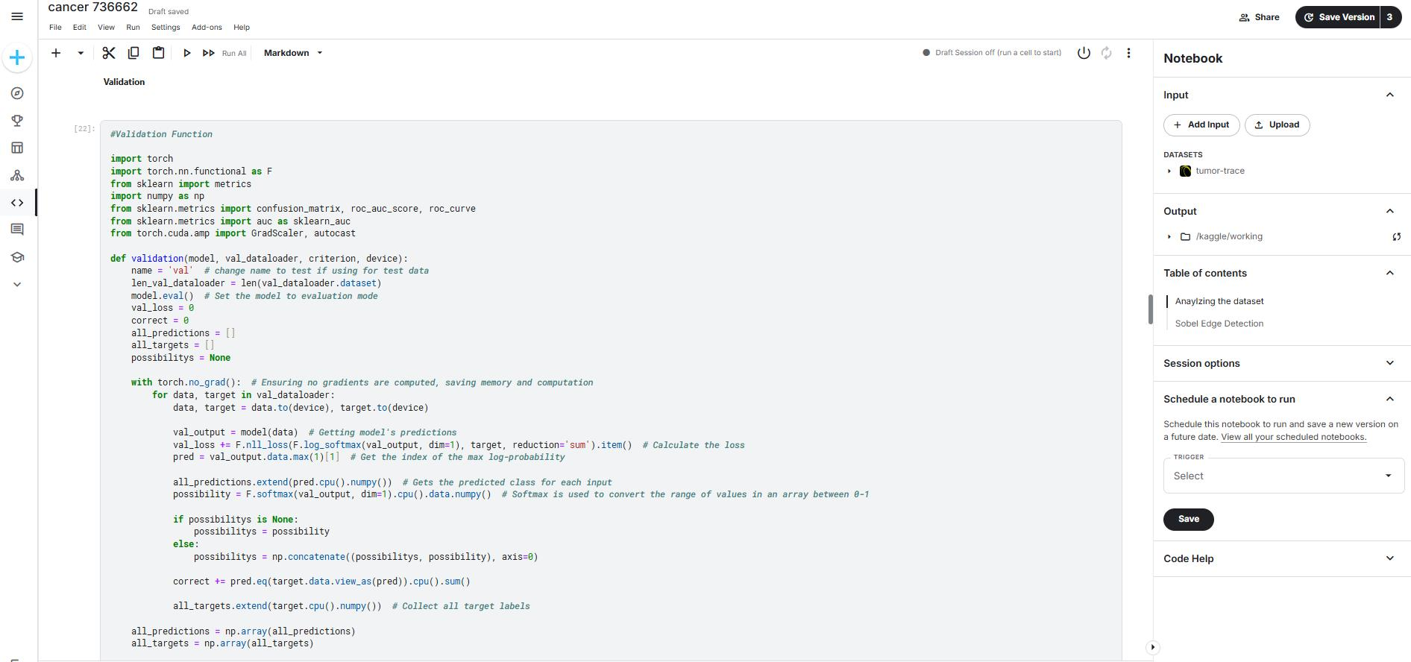

08-11-2024

TRAINING AND VALIDATION OF THE MODEL(VGG16)

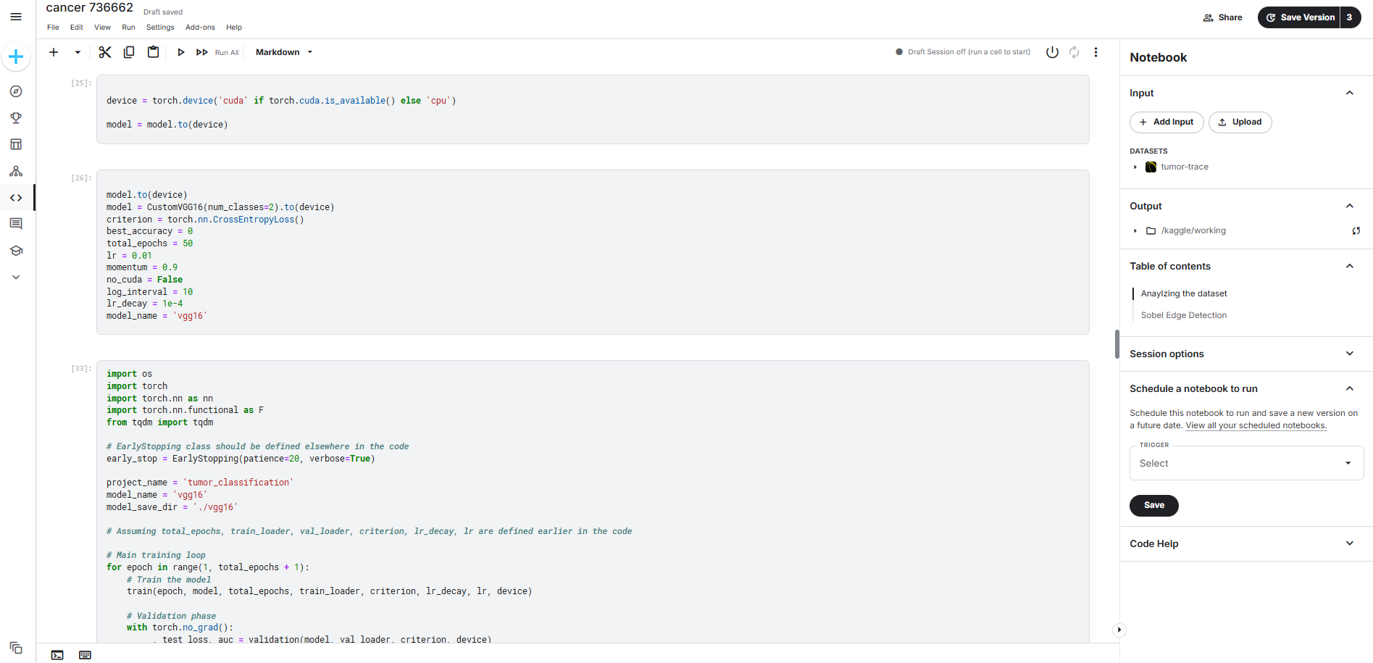

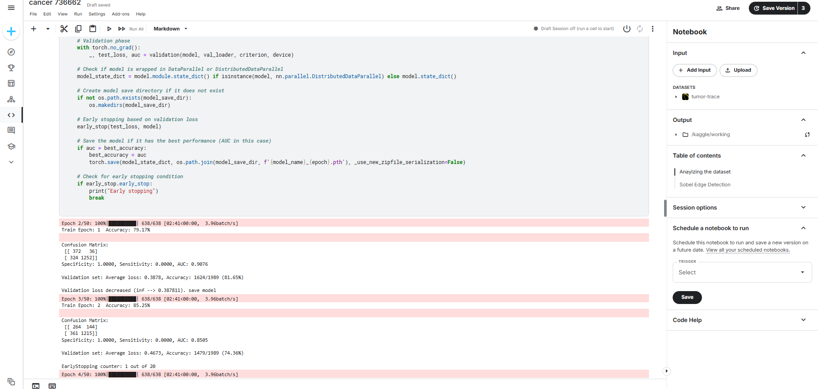

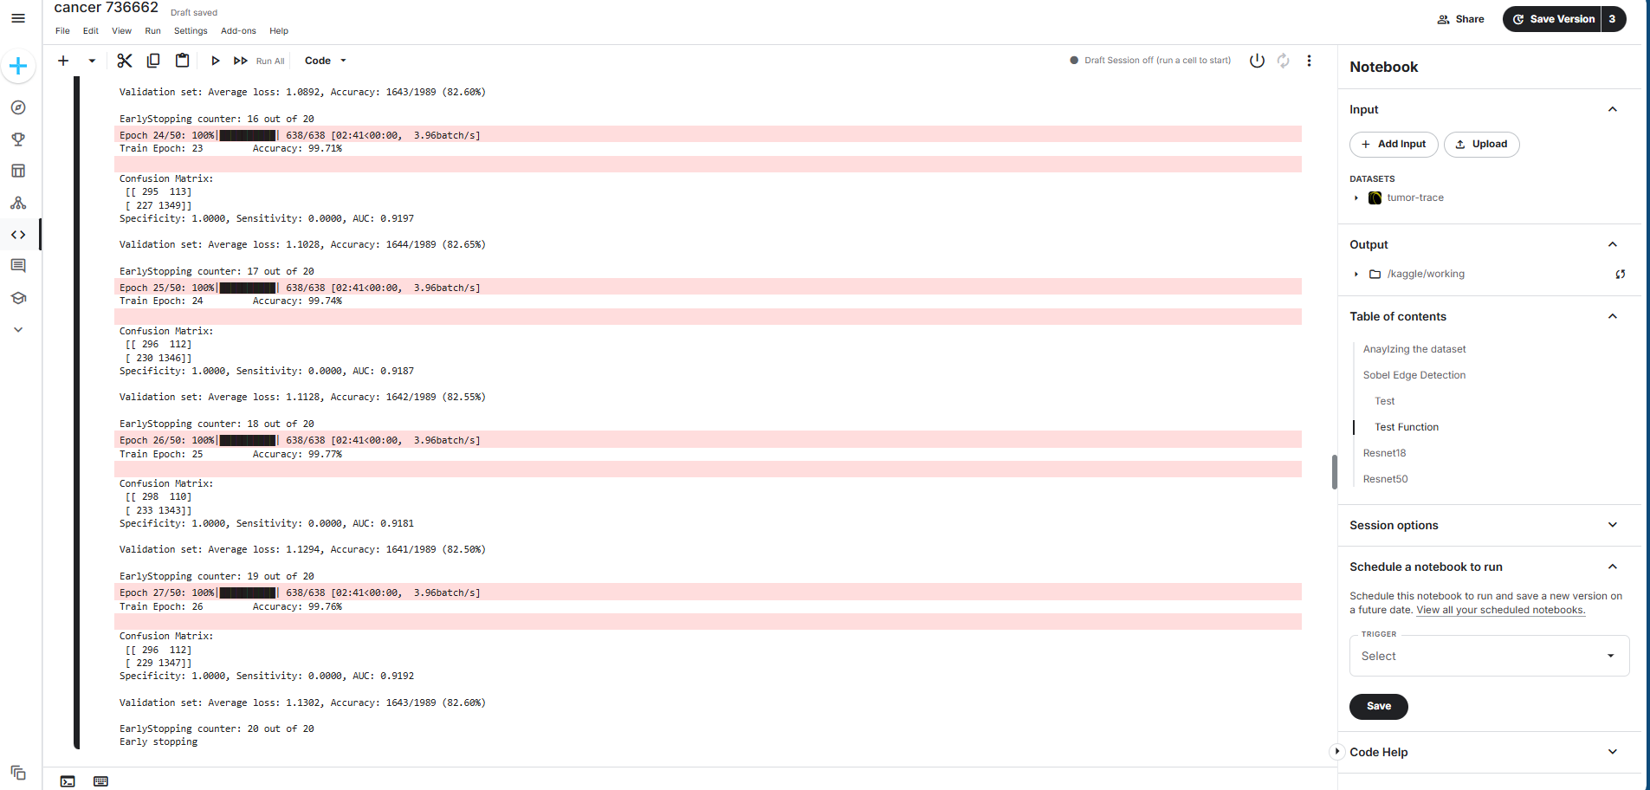

11-11-2024

TRAINING AND VALIDATION OF THE MODEL(RESNET18)

LOADING THE MODEL(RESNET18)

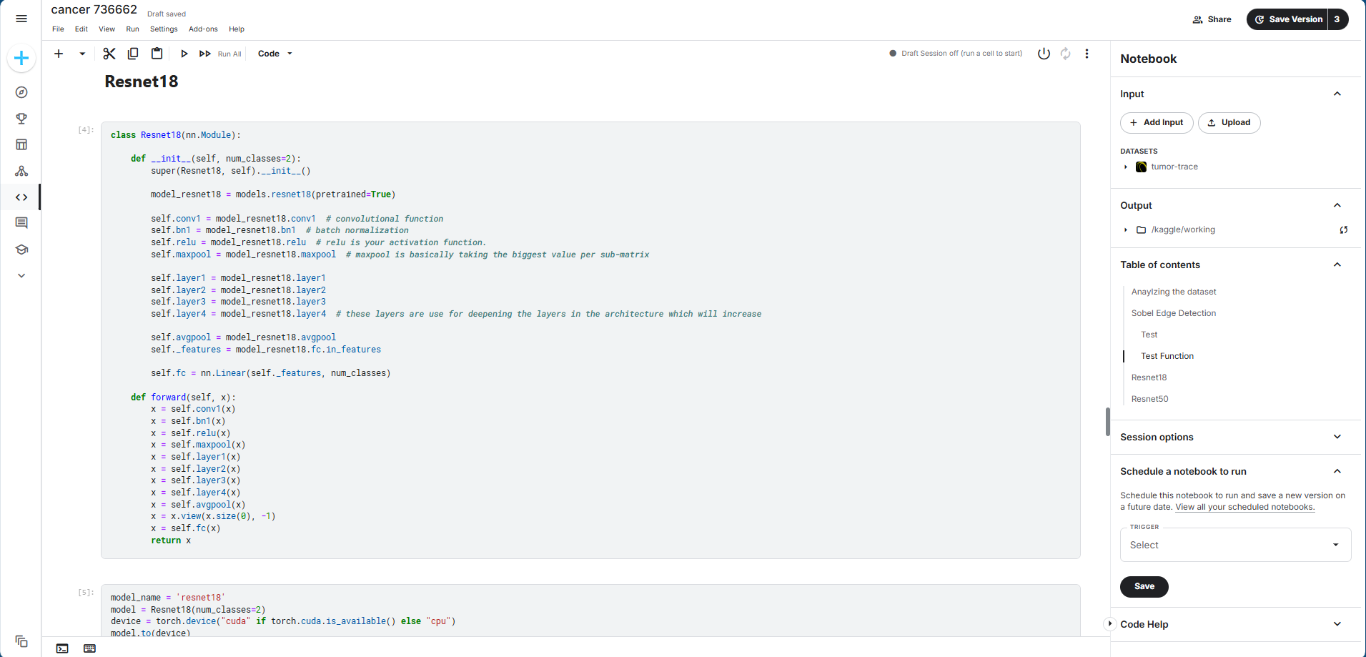

TRAINING THE MODEL

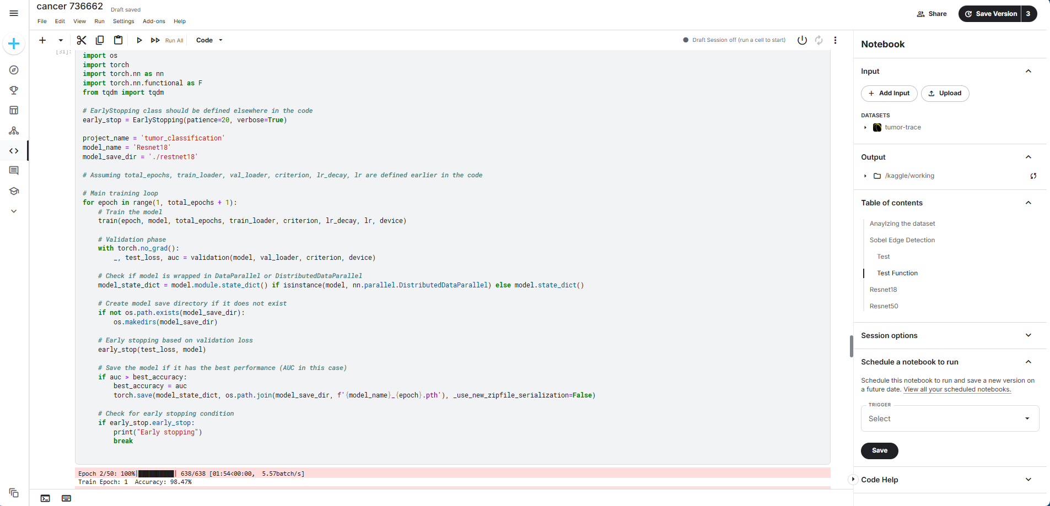

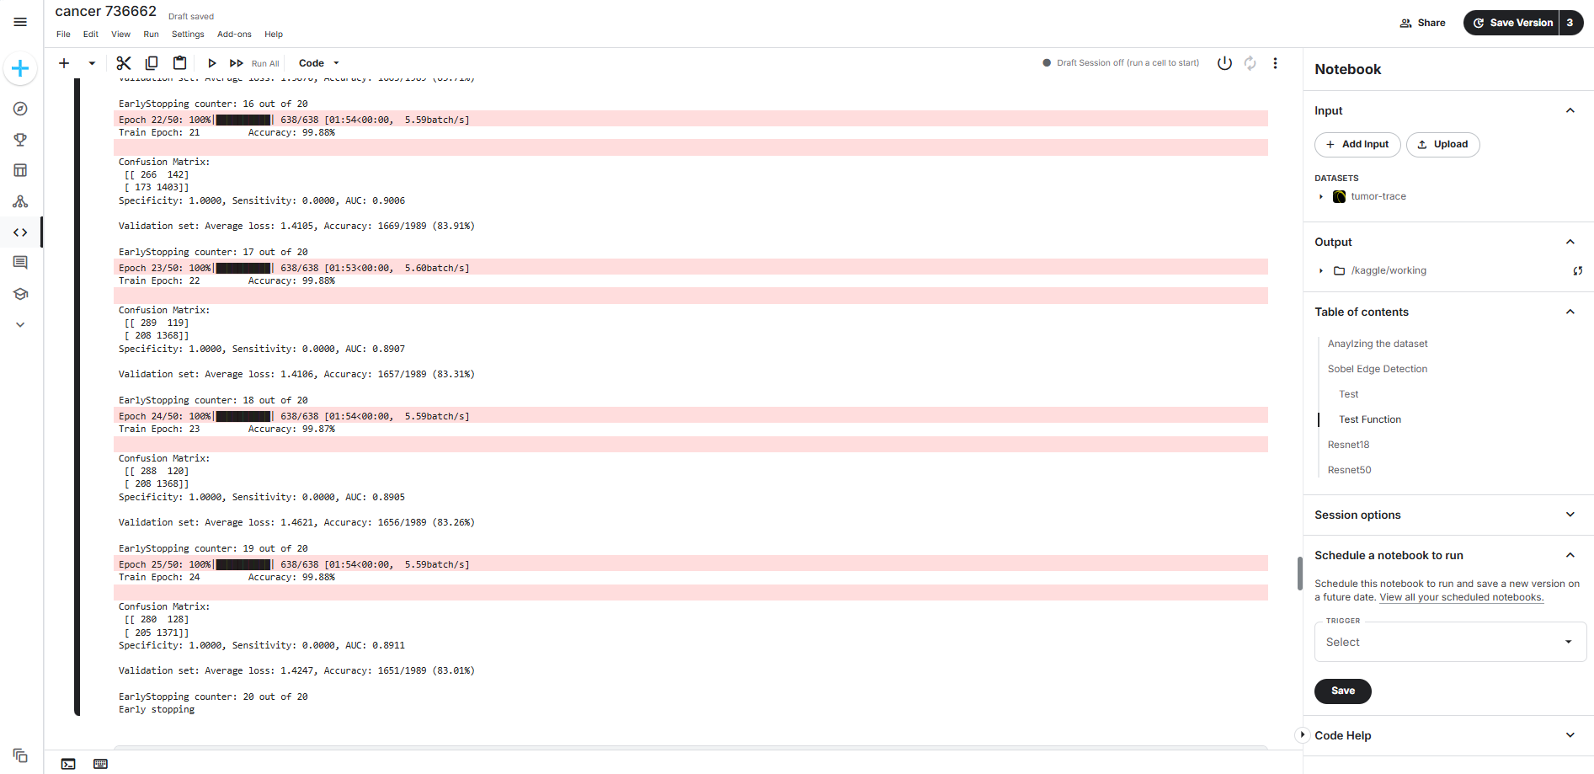

14-11-2024

TRAINING AND VALIDATION OF THE MODEL(RESNET50)

LOADING THE MODEL(RESNET50)

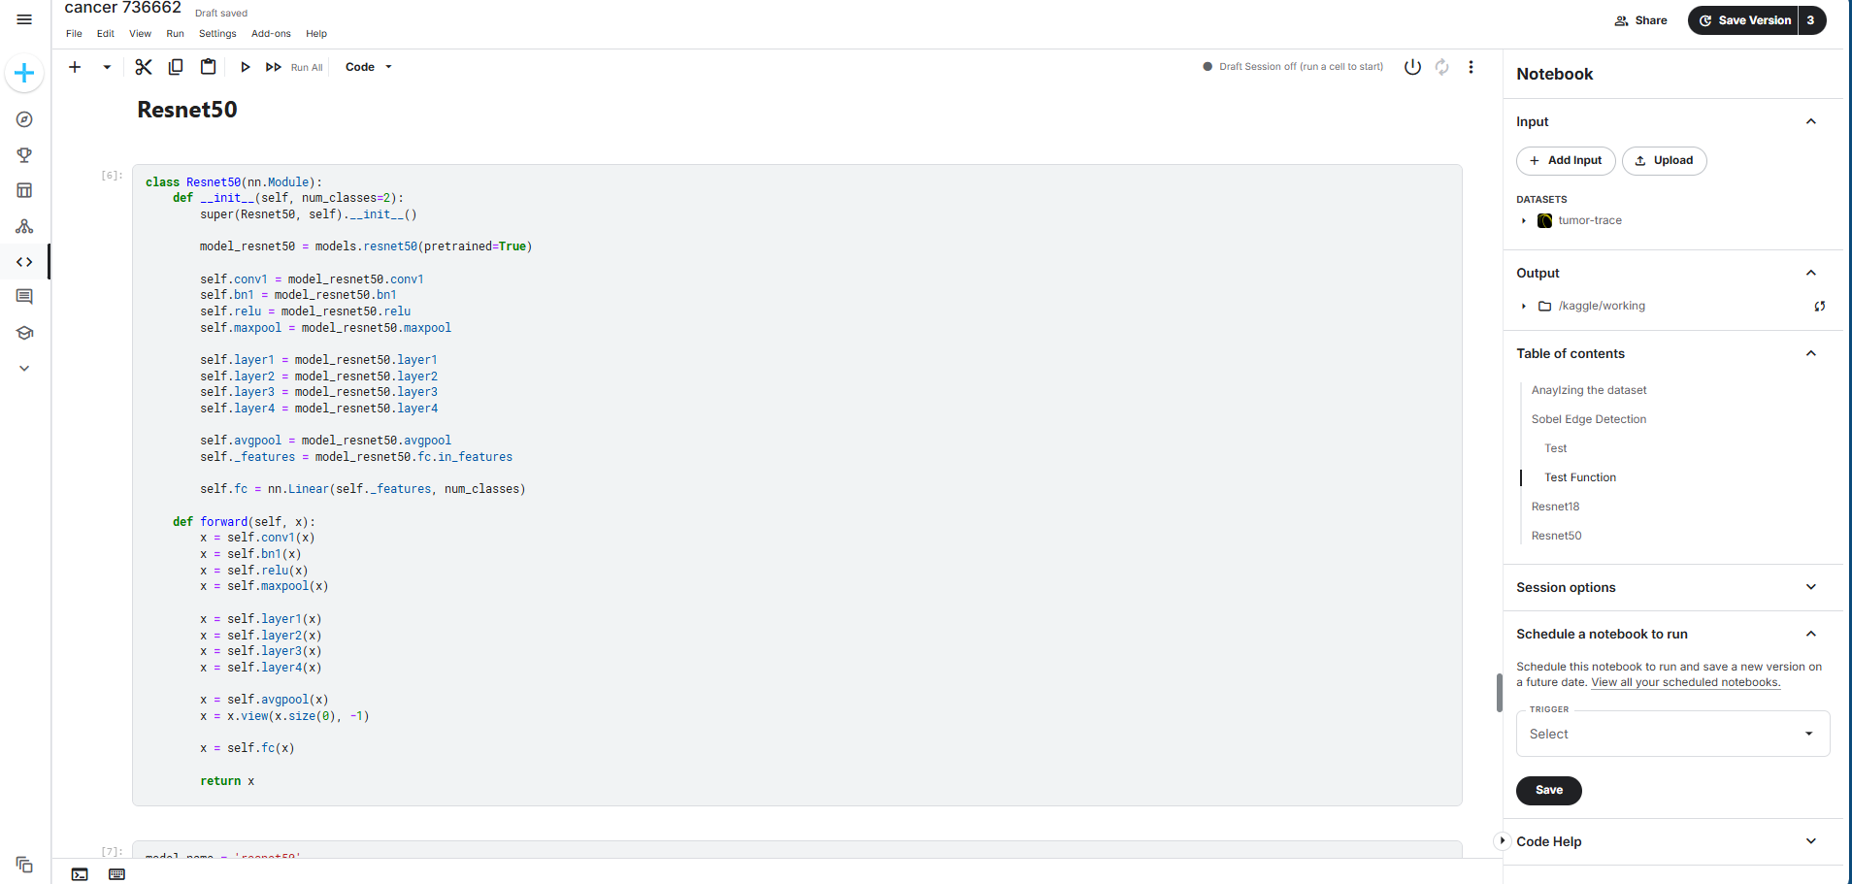

TRAINING THE MODEL(RESNET50)

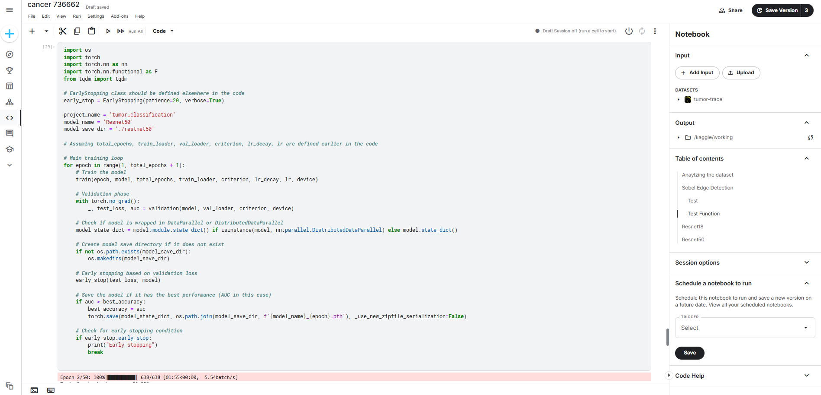

18-11-2024

TESTING THE MODEL(VGG16)

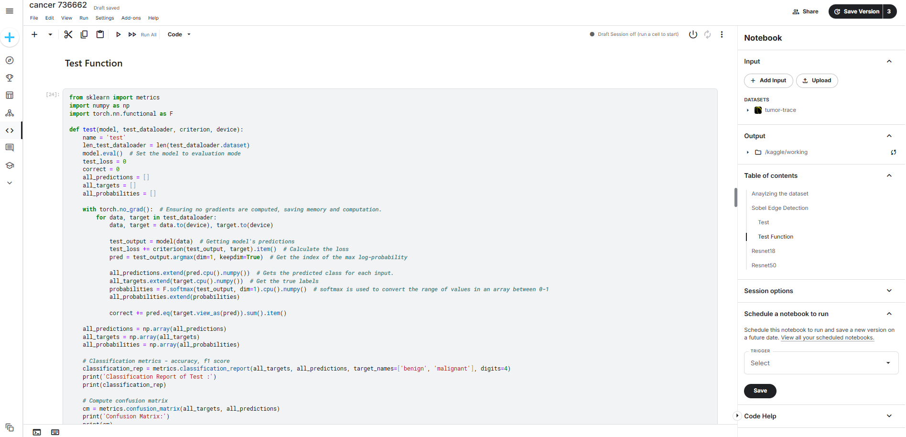

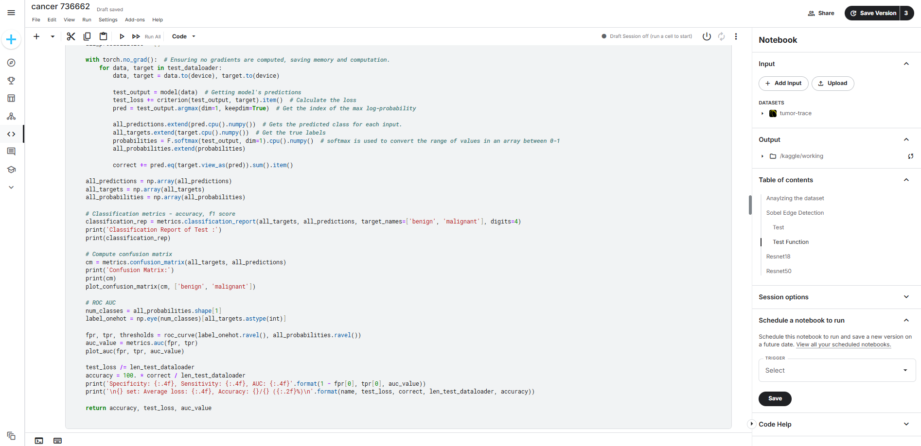

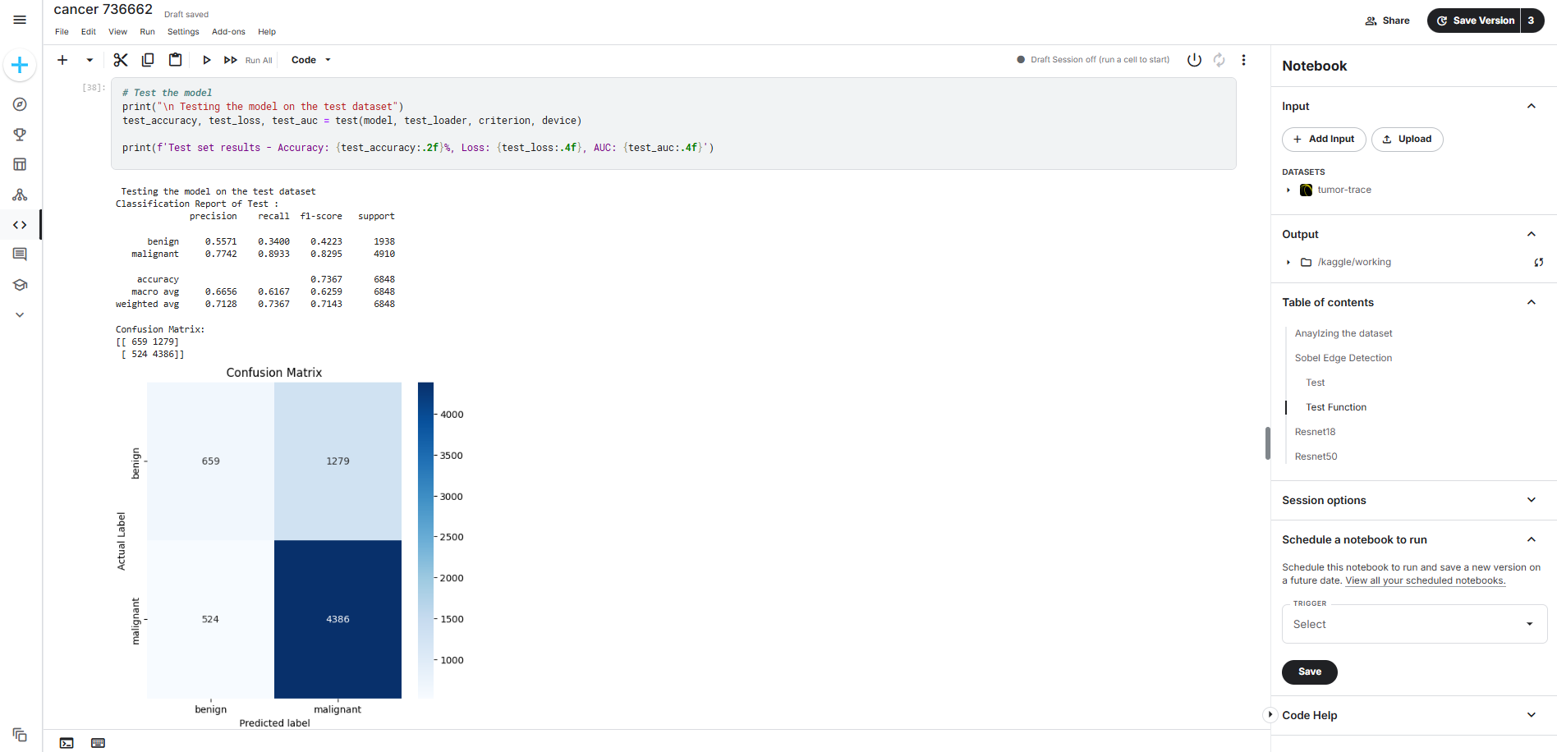

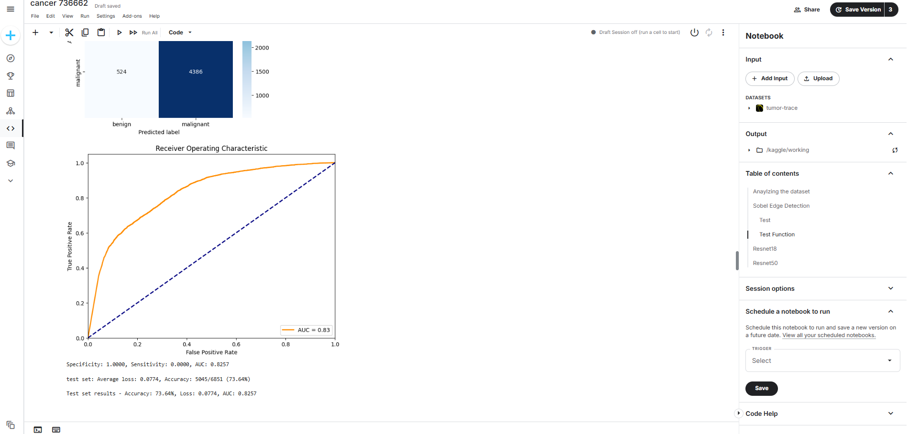

TESTING THE MODEL(RESNET18)

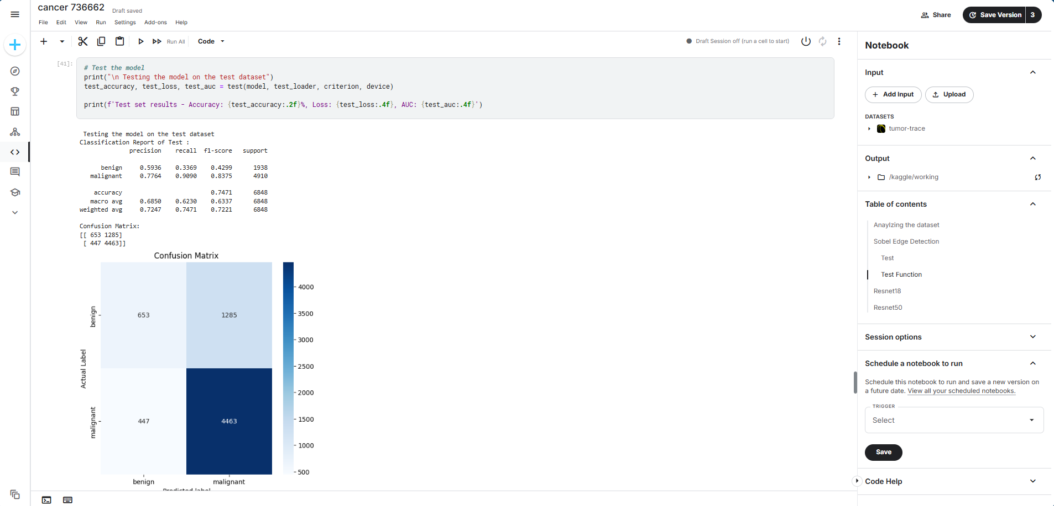

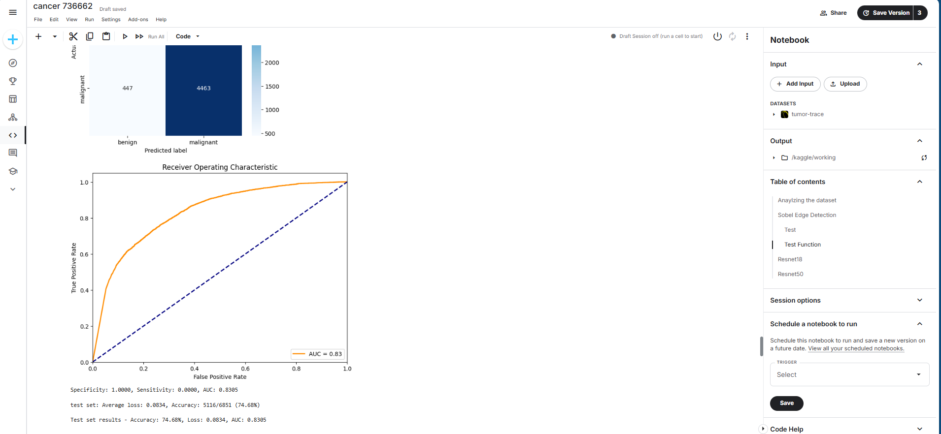

TESTING THE MODEL(RESNET50)

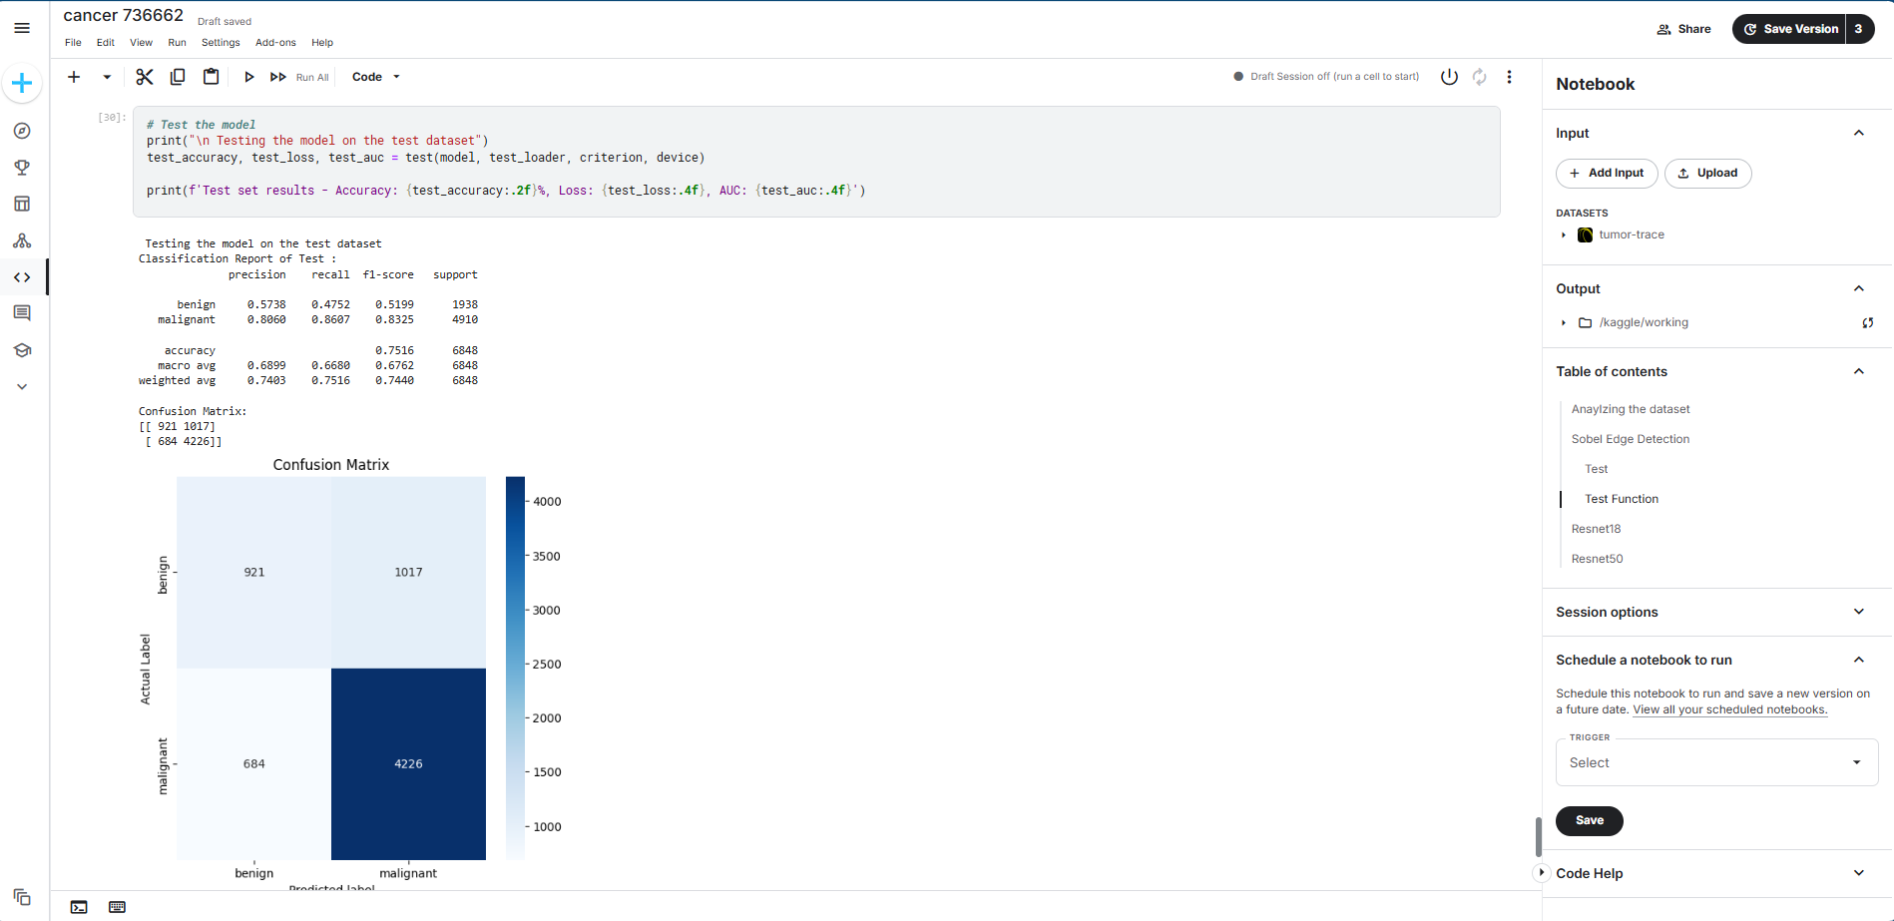

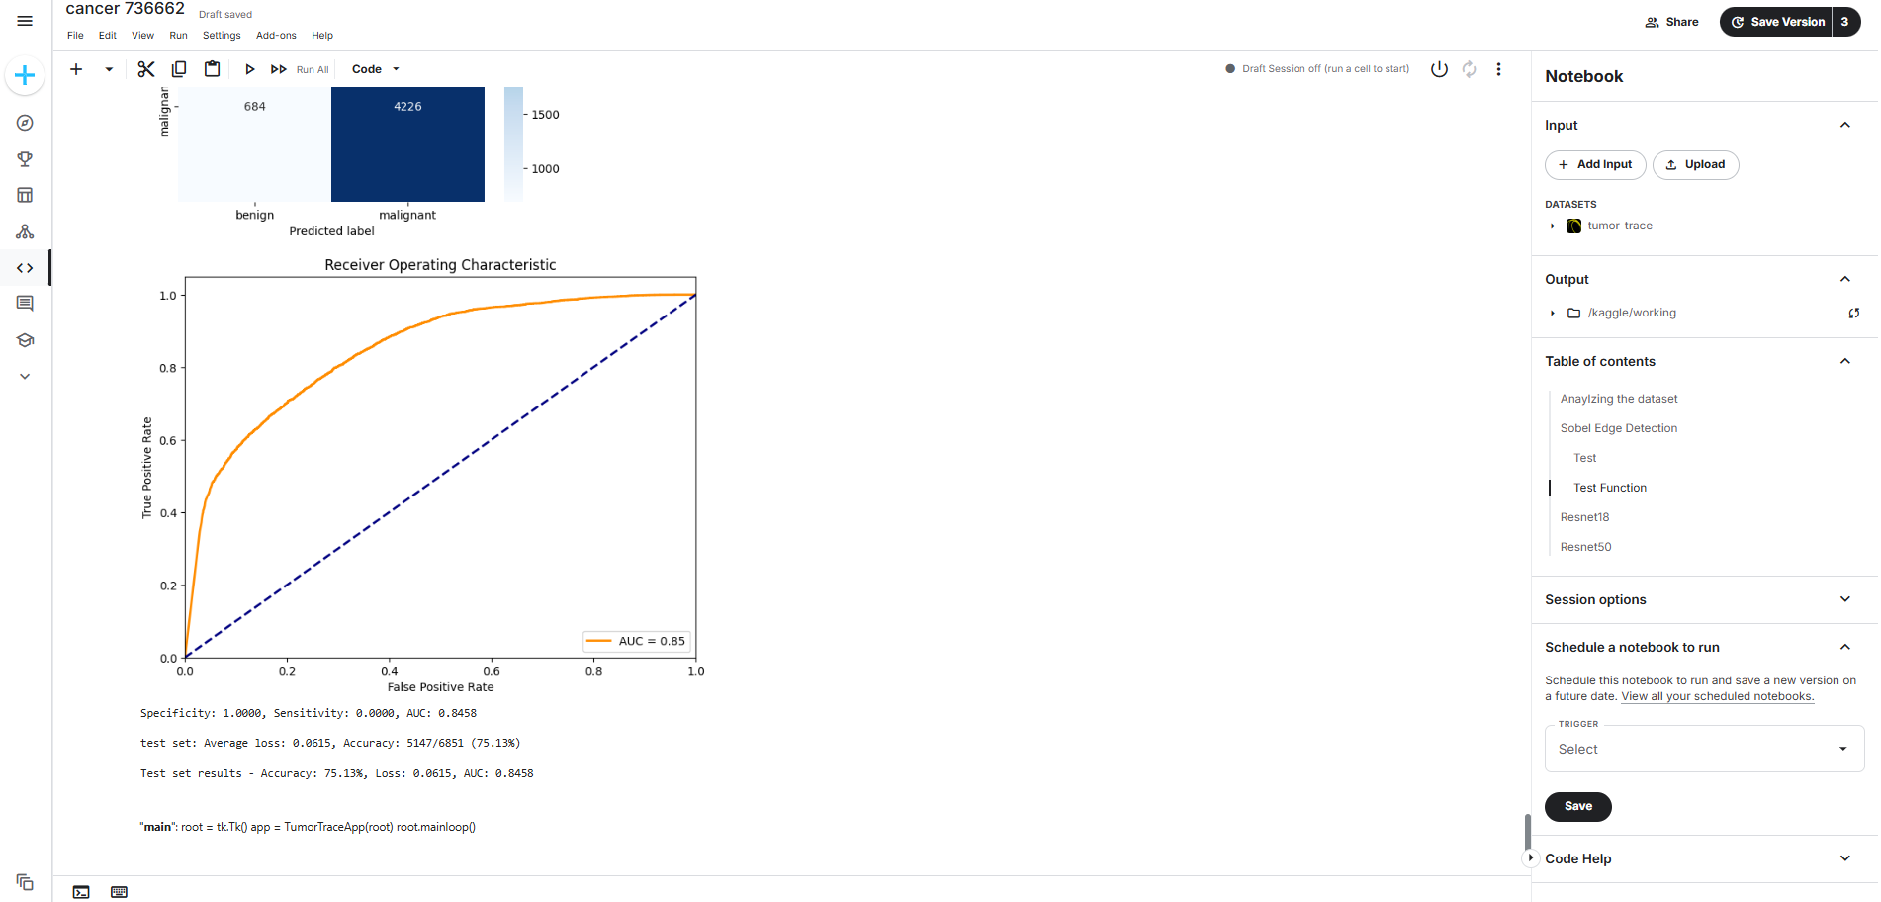

22-11-2024

CREATING A WEB INTERFACE FFOR OUR TRAINED MODEL USING GRADIO

